Normandy Motor Cycle Club (0288)

Date: Sunday 19th May 2024 Permit No. 203133

Name of Event. May Club Trial Start Time 10:30 am

OFFICIALS
Club Stewards: R H Thomas
Clerk of the Course: Mick Auger 89068
Secretary of the Meeting: Mick Auger, 25 Spring Avenue, Egham, Surrey, TW20 9PJ
07970 092132

SUPPLEMENTARY REGULATIONS

JURISDICTION: Open to all paid up members of the Normandy and Thames Motor Cycle Clubs and invited guests (subject to availability) riding solo and sidecar machines.

The event will be held under the National Sporting Code, Environmental Code, Standing

Regulations ACU Adult and Youth Division, regulations of the organising Centre, these Supplementary Regulations and any final Instructions which may be issued.

- ENTRIES: email this completed form to entries@normandymcc.co.uk then transfer entry fee
(Adult £ 25:00, Youth £20:00, Sidecars £30) to:
Normandy MCC Ltd. Lloyds Bank: Account No. 67484460 Sort Code: 30-93-74 Ref: May Club Trial
Limited to 50 riders Opens 31st March Closes 10:30 on 19th May or when full

- COURSE: The Old Quarry, Betchworth nr Dorking, Surrey, RH3 7HD.

- MARKING: Will be by the 0 - 1 - 2 - 3 – 5. TSR22B NON-STOP Marking system will be used. All queries are to be taken up with the Clerk of the Course whose decision will be Final. Scoring will be by individual score cards issued at the start and deposited in a box at the end of the trial.

- AWARDS: Any awards at the discretion of the club.

- PETROL: NOT AVAILABLE at the start.

- FINAL INSTRUCTIONS: These may be given at the start.

 | MOTORCYCLE SPORT EVENT ENTRY FORM  (minimum information requirements)  Auto-Cycle Union Ltd, ACU House, Wood Street, Rugby, Warwickshire CV21 2YX  Tel: 01788 566400 Fax: 01788 573585 E-mail: admin@acu.org.uk | 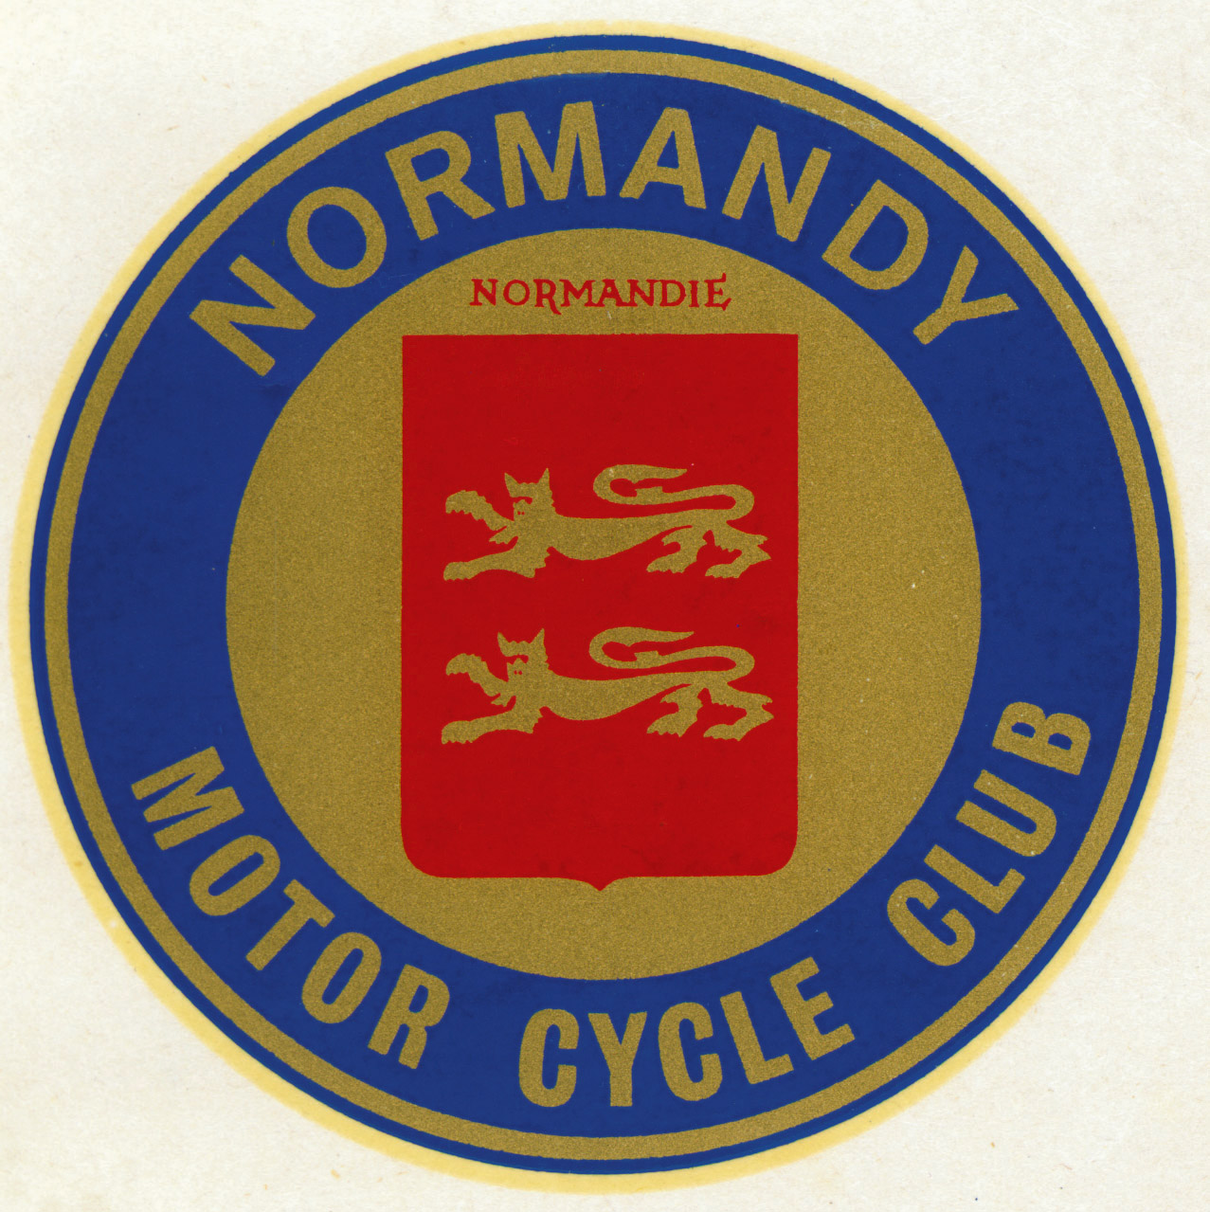

Event:… May Club Trial…………………………… | Organisers:… Normandy MCC
Venue:… The Old Quarry, Betchworth, Surrey, RH3 7HD | Date of Event:…Sunday 19th May 2024
Permit No: 203133 | Course Lic/Cert No. (if applicable):……N/A

This event is held under the National Sporting Code of the Auto-Cycle Union, the Standing Regulations, Supplementary Regulations,
Covid-19 Crisis Risk Assessment and any Final Instructions issued for the meeting.
The ACU National Sporting Code and Standing Regulations are published annually in the ACU Handbook.

Entry declaration: I / we the undersigned apply to enter the event described above and in consideration thereof: -
- I / we hereby declare that I / we have had the opportunity to read, and that I / we understand the National Sporting Code of the ACU, the ACU Standing Regulations, such Supplementary Regulations as have or may be issued for the event, and agree to be bound by them.
- I / we further declare that I am / we are physically and mentally fit to take part in the event and I am / we are competent to do so.
- I / we confirm that I / we understand the nature and type of event we are entering and its inherent risks and agree to accept the same notwithstanding that such risks may involve negligence on the part of the organisers or officials.
- I / we confirm that the machine(s) as described below which I / we compete on shall be suitable and proper for the purpose.
- I / we confirm that if any part of the event takes place on a public highway, the machine(s) described below shall be insured as required by the Road Traffic Acts, or equivalent legislation, and that it / they will comply with the regulations in respect thereof.
- I / we agree that I am / we are required to register our arrival by reporting to event control not less than 30 minutes prior to commencement of my/our practice or first competition, whichever occurs first.
- I confirm that I am not suspended or my ACU Licence has not been suspended / withdrawn from any ACU competition
- I confirm that I have read the Covid-19 Crisis Risk Assessment for this trial and agree to be bound by them which includes social distancing and understand that should I fail to abide by them or any instructions from event officials that I will be disqualified and may face further ACU disciplinary action
- I understand that despite the precautions taken by the club and other riders, I may be exposed to the Covid-19 virus.
- I confirm that I am not unwell or suffering any symptoms of Covid-19 and will bring my own first aid kit for any minor injuries I may suffer

Acknowledgement of the risks of motor sport: I / we understand that by taking part in this event I / we are exposed to a risk of death, becoming permanently disabled or suffering some other serious injury and I / we acknowledge that even in the event that negligence on the part of the ACU, the promoter, the organising club, the venue owner, or any individual carrying out duties on their behalf were to be a contributory cause of any serious injury I / we may suffer, the dominant cause of any serious injury will always be my / our voluntary decision to take part in a high risk activity.

I / we have read the above and acknowledge that my / our participation in motor sport is entirely at my / our own risk.

Rider’s signature: * * If under 18 state date of birth*:

* For riders under 18 years of age - I accept the above conditions of entry to this event and give my approval:-

Signature of parent or person with parental Responsibility:

Riders under 18 years of age who cannot produce a valid ACU Competition Licence/Trials Registration must also complete a ‘Parental Agreement form (Single Event)’ in addition to this entry form.

Rider Surname:…………………………………………..  First Name(s):………………………………………………  Address:…………………………………………………….  ………………………………………………………………  Post Code:……………… Telephone No:………………….  ACU Licence/Registration No:……………………………..  Name of ACU Affiliated Club  (Of which I am a member):………………………………… | Passenger Surname:…………………………………………..  First Name(s):………………………………………………  Address:…………………………………………………….  ………………………………………………………………  Post Code:……………… Telephone No:………………….  ACU Licence/Registration No:……………………………..  Name of ACU Affiliated Club  (Of which I am a member):…………………………………

Class
Expert – Inter – Clubperson – Novice – Sportsperson - Pre-67 – Twinshock – Sidecar

Youth Expert – Youth Inter – Youth Novice – Youth Beginner

Machine
Make:……………………Capacity:………cc Stroke:……..

ACU and The Auto-Cycle Union are trading names of The Auto-Cycle Union Limited registered under Company No. 00134679;
Registered Office: ACU House, Wood Street, Rugby, Warwickshire CV21 2Y

